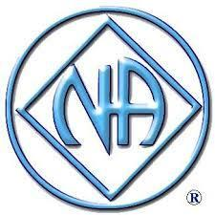

SANTA CRUZ AREA NARCOTICS ANONYMOUS
BIRTHDAY SPEAKER MEETING
JULY 13, 2019 8PM
Mid-County Senior Center,
829 Bay Ave., Capitola

Opening Speaker:
Kaytlyn G.
3 Years, Santa Cruz
Main Speaker:
David K.
9 Years, Sonoma

SPONSORED BY: Surf Camp Committee

HOSTED BY: The Activities Sub-Committee
Chair: Sonja R. (855) 562-2789

